| **National University of Computer and Emerging Sciences** |
| --- |
| Lab Manual  “Triggers” |
|  |
| Database Systems Lab |
| Spring 2024 |

Department of Computer Science

FAST-NU, Lahore, Pakistan

Table of Contents

Objectives 3

Triggers 3

DML Triggers: 4

Syntax of (DML) Triggers: 4

‘Instead of’ and ‘After’ Triggers: 4

DML trigger Option: 4

Getting the affected tables inside the triggers: 7

DDL Triggers 10

Syntax Of DDL 10

Triggers: 11

References: 11

# **Objectives**

The purpose this lab is to know, how the triggers work, types of triggers, how to create a trigger and what are the uses of triggers.

# **Triggers**

Triggers are special kind of stored procedures that automatically execute when a DML or DDL statement associated with the trigger is executed. Each trigger will be associated with one DML or DDL statement. Unlike stored procedure triggers cannot be executed directly by application/user, they will ONLY be executed by DBMS in reaction to DML or DDL statement with which the trigger was associated.

Triggers can be divided in two categories depending on the type of statement they are associated with as follow:

* DML triggers
* DDL triggers

We shall use the schema from the last lab’s manual. Which is as follows.

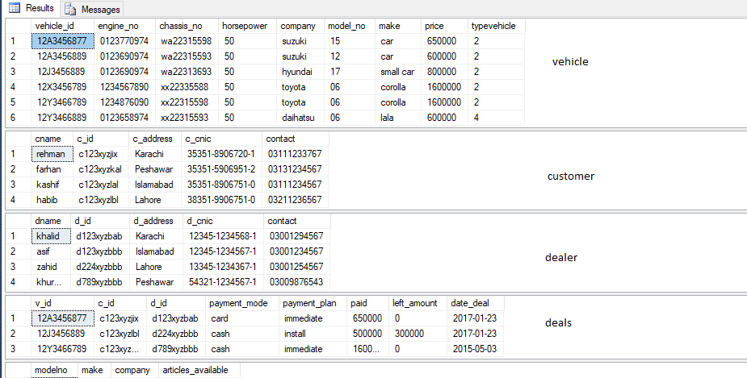

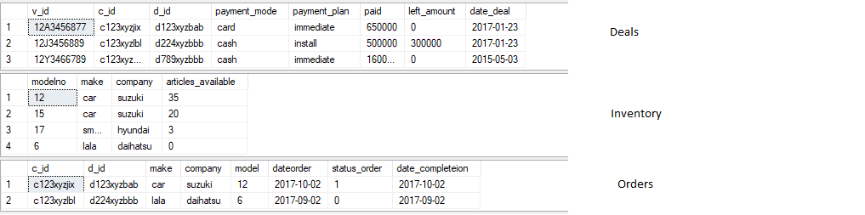

# DML Triggers:

DML is the data modification language that uses queries like INSERT, UPDATE, DELETE. The DML triggers are used to handle these kind of queries.

# Syntax of (DML) Triggers:

CREATE [ OR ALTER ] TRIGGER [ schema_name . ]trigger_name

ON { table }

[ WITH <dml_trigger_option> [ ,...n ] ]

{ FOR | AFTER }

{ [ INSERT ] [ , ] [ UPDATE ] [ , ] [ DELETE ] }

AS { sql_statement [ ; ] [ ,...n ] }

<dml_trigger_option> ::=

[ NATIVE_COMPILATION ]

[ SCHEMABINDING ]

[ EXECUTE AS Clause ]

# ‘Instead of’ and ‘After’ Triggers:

You must have noticed the word after and instead of in the syntax of the trigger creation given above.

The instead of trigger is shot by stopping the action on which the trigger is created. However, the after trigger is shot after the action on which the trigger is created is complete.

## DML trigger Option:

The DML trigger option given in the above syntax is used to specify the action on which the trigger is to be shot.

Now let us look at the triggers a little closely how they practically work.

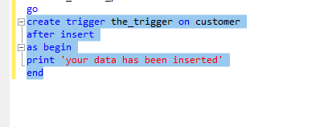

The trigger has been made as to be shot on the insert query on the customer table. Now if we insert anything in the customer table as soon as a new customer has been added in the table this trigger shall be shot.

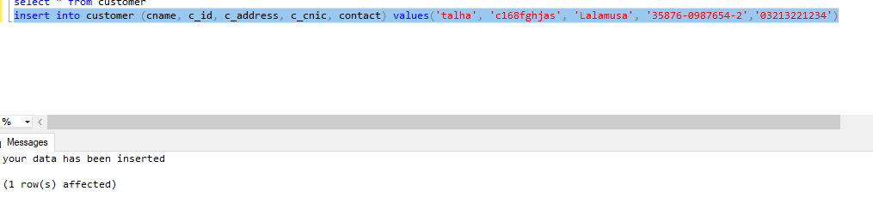

In the above example you can clearly see that we have just inserted a new entry in the table customer but the trigger has been shot that too after the trigger has been shot.

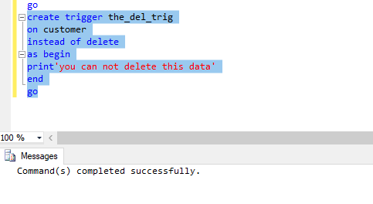

Now we have created another trigger on the same table but on a different action. Note that this is an instead of trigger it will not execute the query.

The data currently in the table.

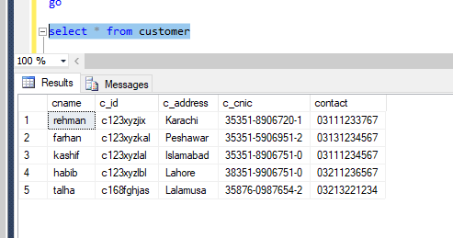

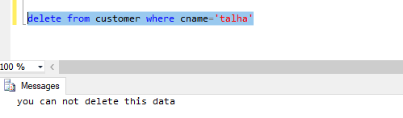

The data after this query

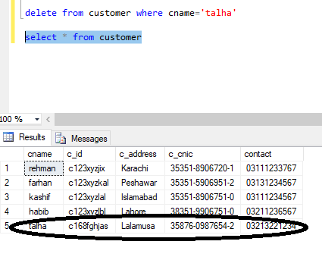

In the above example, it can be seen that the data has not been deleted form the table because the trigger was of the type instead of.

# Getting the affected tables inside the triggers:

The triggers we have seen above are simple one, what if you want the value of effect rows from DML and use them in triggers.

*Example: Whenever a customer is inserted in, it should automatically convert that name of that instructor in Upper Case.*

*For example: customer with Name “ali ahmed” should be inserted as “ALI AHMED”*

For that we use special table “DELETED” and “INSERTED” designed for DML triggers.

DML triggers use the **deleted** and **inserted** logical (conceptual) tables. They are structurally similar to the table on which the trigger is defined, that is, the table on which the user action is tried. The **deleted** and **inserted** tables hold the old values or new values of the rows that may be changed by the DML action.

More details

<http://technet.microsoft.com/en-us/library/ms191300.aspx>

NOTE: These tables are only accessible in triggers

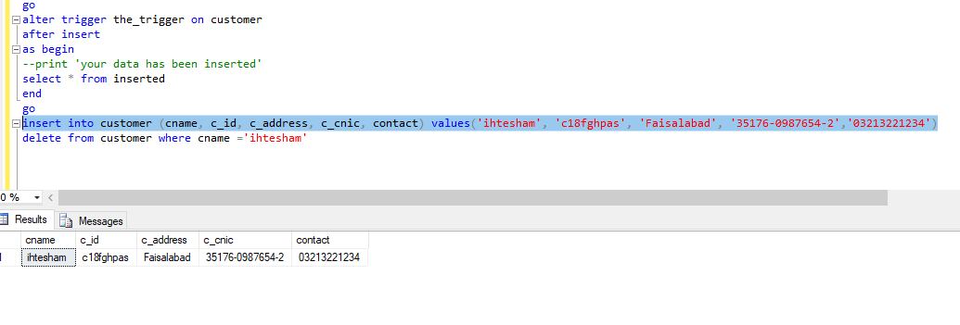

So far we have seen triggers on a single action a single trigger can be used to cater multiple actions.

Before moving forward you must know that only one trigger can be made on a particular action on a table so in order to make a new trigger on the same action we should either alter the previous trigger or drop the previous trigger or disable it. The syntax for these are as follows.

ALTER <TriggerName>

On <view/table>

After/Instead of <insert/update/delete>

As

begin

<Body>

end

Drop trigger <TriggerName>

Enable trigger <TriggerName> on <ObjectName>

Disable trigger <TriggerName> on <ObjectName>

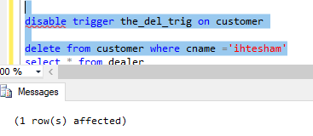

See now after disabling the trigger the data can be easily deleted from the tables.

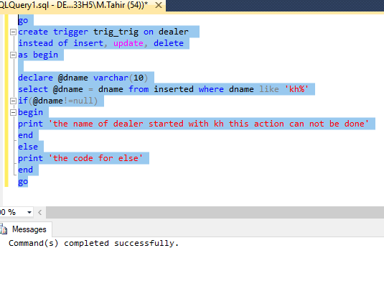

The above example shows how a trigger on a table for multiple actions can be made. Now let us see the effect of the given trigger.

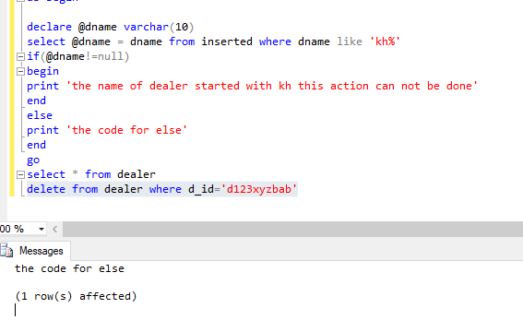

The given id is for khalid but the else fragment was run because the column dname was not included in the temporary table insert.

# DDL Triggers

DDL triggers, fire in response to a DDL statement to which they are associated. DDL event primarily correspond to SQL statements that start with the keywords CREATE, ALTER, and DROP. These triggers are current databases.

There triggers are also of two types, FOR and AFTER, first one executes instead of the DDL statement it is associated with and second one executes after the DDL statement, it is associate with is successfully executed.

(For in DML FOR is same as Instead of in DDL)

Use DDL triggers when you want to do the following:

* You want to prevent certain changes to your database schema.
* You want something to occur in the database in response to a change in your database schema.
* You want to record changes or events in the database schema.

## Syntax Of DDL

CREATE TRIGGER *trigger_name*

ON DATABASE

{ FOR | AFTER } { *event_type*} [ **,**...*n* ]

AS

Begin

<Body>

End

## Triggers:

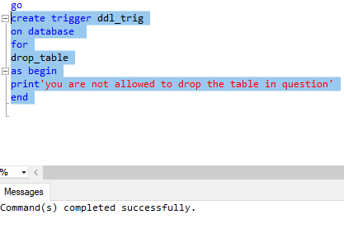

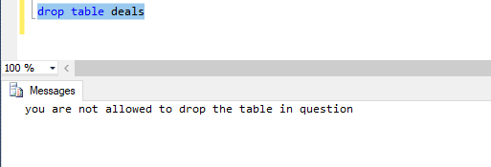

# References:

<https://msdn.microsoft.com/en-us/library/bb522542.aspx>